**Lab - 11**

**Project**

* Consider the following set of requirements for a UNIVERSITY database that is used to keep track of students' transcripts.

**Description**:

1. The university keeps track of each student's name, student number, Social Security number, current address and phone number, permanent address and phone number, birth date, sex, class (freshman, sophomore, ..., graduate), major department, minor department (if any), and degree program (B.A., B.S., ..., Ph.D.). Some user applications need to refer to the city, state, and ZIP Code of the student's permanent address and to the student's last name. Both Social Security number and student number have unique values for each student.

b) Each department is described by a name, department code, office number, office phone number, and college. Both name and code have unique values for each department.

c) Each course has a course name, description, course number, number of semester hours, level, and offering department. The value of the course number is unique for each course.

d) Each section has an instructor, semester, year, course, and section number. The section number distinguishes sections of the same course that are taught during the same semester/year; its values are 1, 2, 3, ..., up to the number of sections taught during each semester.

e) A grade report has a student, section, letter grade, and numeric grade (0, 1, 2, 3,or 4).

1. Draw an ER diagram for the schema(Make sure to use correct notation for specifying cardinality ratios, total/partial participations, key constraints.)

|  |  |
| --- | --- |
|  | |
|  |  |
|  | |

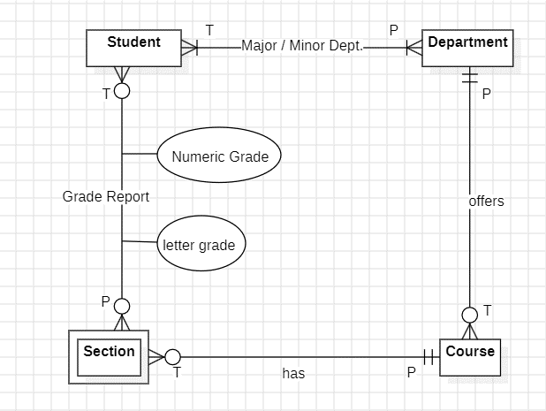

1. Design the relational schema for this application.

|  |
| --- |
| STUDENT(StudentID, SSN,  FirstName, LastName,  CurrentAddress, CurrentPhone,  PermanentAddres, PermanentPhone,  BirthDate, Sex, Class,  MajorDept, MinorDept,  DegreeProgram) |
| DEPARTMENT(DepartmentCode, DepartmentName,  OfficeNumber, OfficePhone, College) |
| COURSE( CourseNumber, CourseName,  Description, SemesterHours,  Level, OfferingDept) |
| SECTION(SectionNumber , CourseNumber,  Instructor, Semester, Year) |
| GRADEREPORT(StudentID, SectionID, CourseNumber  LetterGrade, NumericGrade) |

1. Create tables in SQL for all the relations along with constraints.

|  |  |
| --- | --- |
| QUERY | CREATE TABLE U_Department (  DepartmentCode NUMBER(10) PRIMARY KEY,  DepartmentName VARCHAR2(50) UNIQUE NOT NULL,  OfficeNumber VARCHAR2(10) NOT NULL,  OfficePhone CHAR(10) NOT NULL,  College VARCHAR(50) NOT NULL  ); |
| OUTPUT |  |
|  |

|  |  |
| --- | --- |
| QUERY | CREATE TABLE u_student (      StudentID NUMBER(12) PRIMARY KEY,      SSN CHAR(9) UNIQUE NOT NULL,      FirstName VARCHAR2(50) NOT NULL,      LastName VARCHAR2(50),      CurrentAddress VARCHAR2(100) NOT NULL,      CurrentPhone CHAR(10) NOT NULL,      PermanentAddress VARCHAR2(100),      PermanentPhone CHAR(10),      BirthDate DATE NOT NULL,      Sex CHAR(1) NOT NULL,      Class VARCHAR(20) NOT NULL,      MajorDepartment NUMBER(10),      MinorDepartment NUMBER(10),      CONSTRAINT u_student_maj_dept      DegreeProgram VARCHAR(10) NOT NULL,          FOREIGN KEY(MajorDepartment)          REFERENCES U_Department(DepartmentCode),      CONSTRAINT u_student_min_dept          FOREIGN KEY(MinorDepartment)          REFERENCES U_Department(DepartmentCode)  ); |
| OUTPUT |  |
|  |

|  |  |
| --- | --- |
| QUERY | CREATE TABLE u_course (  CourseNumber NUMBER(15) PRIMARY KEY,  CourseName VARCHAR2(100) NOT NULL,  Description VARCHAR2(255) NOT NULL,  SemesterHours NUMBER(6) NOT NULL CHECK(SemesterHours > 20),  "Level" VARCHAR2(20) NOT NULL,  OfferingDepartment NUMBER(10),  CONSTRAINT offering_dept_fk  FOREIGN KEY(OfferingDepartment)  REFERENCES u_department(DepartmentCode)  ); |

|  |  |
| --- | --- |
| OUTPUT |  |
|  |

|  |  |
| --- | --- |
| QUERY | CREATE TABLE u_section (  SectionNumber NUMBER(10),  CourseNumber NUMBER(15),  Instructor VARCHAR(50) NOT NULL,  Semester VARCHAR(10) NOT NULL,  Year NUMBER(2) NOT NULL,  CONSTRAINT section_course_fk  FOREIGN KEY(CourseNumber)  REFERENCES u_course(CourseNumber),  CONSTRAINT section_course_pk  PRIMARY KEY (CourseNumber, SectionNumber)  ); |
| OUTPUT |  |
|  |

|  |  |
| --- | --- |
| QUERY | CREATE TABLE u_grade (  StudentID NUMBER(12) NOT NULL,  SectionNumber NUMBER(10) NOT NULL,  CourseNumber NUMBER(15) NOT NULL,  LetterGrade CHAR(2),  NumericGrade NUMBER(3),  CONSTRAINT grade_student_fk  FOREIGN KEY (StudentID)  REFERENCES u_student(StudentID),  CONSTRAINT grade_section_fk  FOREIGN KEY (SectionNumber, CourseNumber)  REFERENCES u_section(SectionNumber, CourseNumber),  CONSTRAINT grade_course_st_pk  PRIMARY KEY (StudentID, CourseNumber, SectionNumber)  ); |

|  |  |
| --- | --- |
| OUTPUT |  |
|  |